Gradient Descent
Table of Contents
Intuition 2
Formulae 3
Learning Rate 4
Generic Functions 6
Number of Iterations 7
Derivatives 7
Batch vs Stochastic vs Mini-Batch Gradient Descent 8

As a reminder, our objective is to find $\min_{θ_{0}, θ_{1}}{J\left(θ_{0}, θ_{1}\right)}$. Although we are currently using gradient descent for just two parameters, it can be used with any number of parameters as well.

Intuition

Consider that we have a convex graph in a 2D space, such as the one above. For such a graph, if we have a point that is on the right-side of the graph, we need to decrease $θ_{0}$ to reach the minima point, and if we have a point that is on the left-side of the graph, we need to increase $θ_{0}$ to reach the minima point.
Another way of looking at this is that we need to subtract the gradient, multiplied by some constant, to find the value of $θ_{0}$ for which we reach the minima point. The gradient on the right side of this graph is positive, while the gradient on the left side of this graph is negative, so subtracting the gradient decreases and increases the value of $θ_{0}$ respectively, which is exactly what we need. If we are already at the minima, the gradient will be $0$, so subtracting it will make no difference.
This is essentially what happens in gradient descent, albeit in a multi-dimensional space.

Formulae
Firstly, we pick a random point $\left(θ_{0}, θ_{1}\right)$. Normally, the point picked is $\left(0, 0\right)$.
Next, we apply the following equations.
$$temp0≔θ_{0}-α\frac{δ}{δθ_{0}}J\left(θ_{0}, θ_{1}\right)$$
$$temp1≔θ_{1}-α\frac{δ}{δ_{1}}J\left(θ_{0}, θ_{1}\right)$$
$$θ_{0}≔temp0$$
$$θ_{1}≔temp1$$
We repeatedly apply the above formula until we reach convergence, i.e. the values of $θ_{0}$ and $θ_{1}$ stop changing.
There’s a whole lot to unpack here, so lets go step-by-step.
Firstly, notice that the assignment operator, $≔$, is being used instead of a normal $=$ sign. This is because we will be using the $=$ sign to show that two values are equivalent.
Secondly, the $α$ here is called the step size or the learning rate. This is a value that we specify. We will get back to the details and significance of this later on.
Finally, we are doing things a little weirdly in the equations above. Why did we take the values of the actual equations and store them in temporary variables, only to go and assign them to $θ_{0}$ and $θ_{1}$ respectively in just the next step? The reason is, at the first equation, if we directly set the result to $θ_{0}$, then we will end up using the new value of $θ_{0}$ to calculate the new value of $θ_{1}$ in the next equation. What we need however, is to use the old value of $θ_{0}$. To deal with that, we have to store the results in temporary variables. What we did above is called a simultaneous update. The actual equation mathematically (ignoring the problems of directly assigning the value) would look like this:
$$θ_{j}≔θ_{j}-α\frac{δ}{δθ_{j}}J\left(θ_{0},…,θ_{n}\right)$$

Learning Rate
Coming back to $α$, the learning rate, this value determines how large the change from one value of $θ_{j}$ to the next value is.

If we set the value to a very small number, then we will need to change $θ_{j}$ many times before we reach the point of convergence.

If we set the value to be too large, then when we get close to the point of convergence, we might overshoot it. Worse still, for extremely large values, we might even diverge instead of converging.
Thus, it would be best if we could somehow have a large value of $α$ towards the start, and gradually decrease it the closer we get to the point of convergence. We can actually do this by setting $α=\frac{1}{t}$, where $t$ is the number of iterations.
Normally though, we set the value of $α$ to a constant $≤1$. This is because as we get close to the point of convergence, the gradient becomes smaller, which in turn makes the changes in $θ_{j}$ automatically smaller without having to modify $α$.

Generic Functions
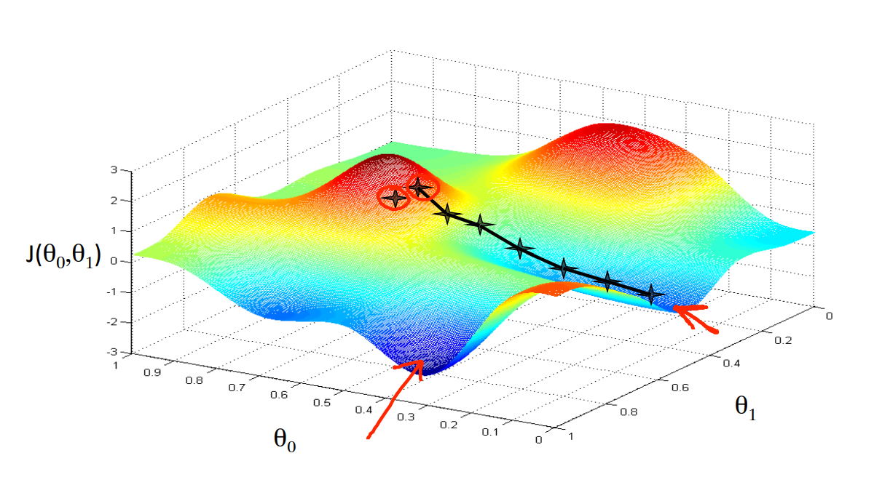
For a random function $J$, we can have multiple local minima. Depending on our starting point $(θ_{0}$, $θ_{1}$), we could end up at different minima. So how do we tell if the minima we are at is the global minima?
One solution could be to repeatedly run the algorithm for different starting values and then take the result which is least.
Luckily for us though, the optimization problems we will be working with are guaranteed to always be a convex shape, as shown below. We will look into the proof for this soon.
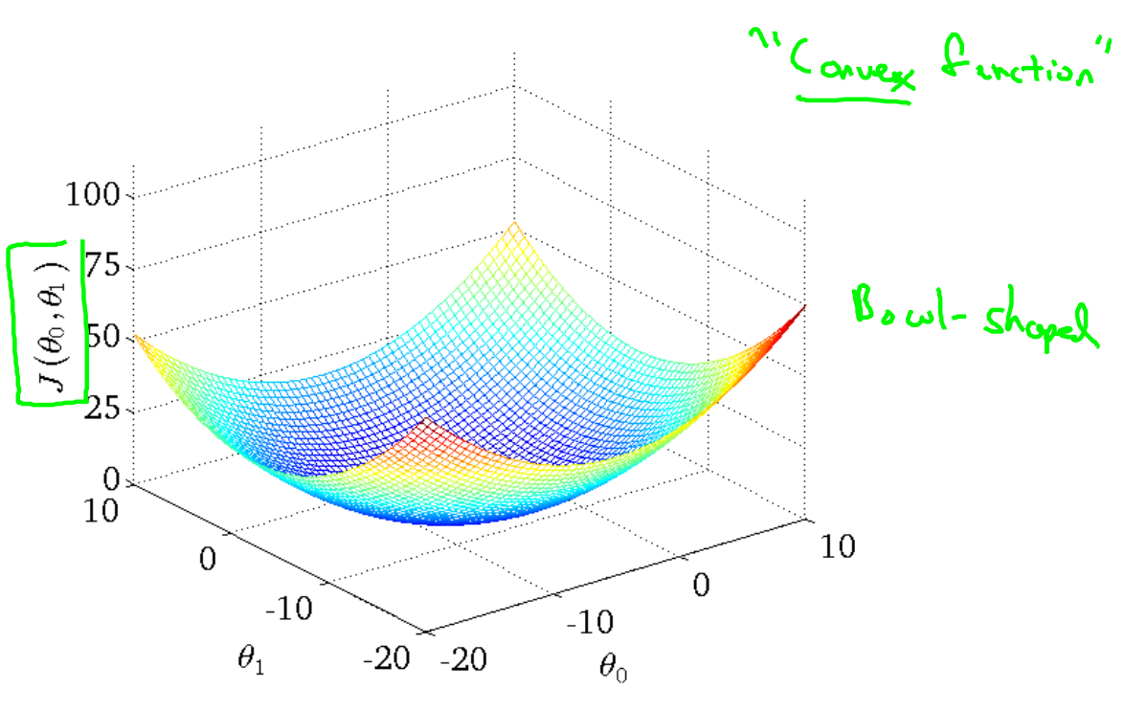

Number of Iterations
What if we end up repeatedly changing $θ_{j}$ by extremely small values and we never fully converge? How long do we keep going?
One way to deal with this could be to set a maximum iteration count, say $100,000$, but even this may be too large.
Another way could be to specify a certain error threshold, say $0.01$. If the change in the value of the cost function, $∇\frac{dJ}{dθ}$, is less than this value, then we stop. This is the level of imperfection in our algorithm that we are willing to accept.

Derivatives
$$\frac{δ}{δθ_{j}}J\left(θ_{0}, θ_{1}\right)=\frac{δ}{δθ_{j}}×\frac{1}{2m}\sum_{i=1}^{m}{{\left(h_{θ}\left(x^{\left(i\right)}\right)-y^{\left(i\right)}\right)}^{2}}=\frac{δ}{δθ_{j}}×\frac{1}{2m}\sum_{i=1}^{m}{{\left(θ_{0}+θ_{1}x^{\left(i\right)}-y^{\left(i\right)}\right)}^{2}}$$
For $j=0$,
$$\frac{δ}{δθ_{0}}=\frac{1}{m}\sum_{i=1}^{m}{\left(h_{θ}\left(x^{\left(i\right)}\right)-y^{\left(i\right)}\right)}$$
For $j=1$,
$$\frac{δ}{δθ_{1}}=\frac{1}{m}\sum_{i=1}^{m}{\left(h_{θ}\left(x^{\left(i\right)}\right)-y^{\left(i\right)}\right)⋅x^{\left(i\right)}}$$

If $x^{\left(i\right)}$ is multi-dimensional, meaning $h_{θ}=θ_{0}+θ_{1}x_{1}+θ_{2}x_{2}+…$,
$$\frac{δ}{δθ_{0}}=\frac{1}{m}\sum_{i=1}^{m}{\left(h_{θ}\left(x^{\left(i\right)}\right)-y^{\left(i\right)}\right)}$$
$$\frac{δ}{δθ_{1}}=\frac{1}{m}\sum_{i=1}^{m}{\left(h_{θ}\left(x^{\left(i\right)}\right)-y^{\left(i\right)}\right)⋅x_{1}^{\left(i\right)}}$$
$$\frac{δ}{δθ_{2}}=\frac{1}{m}\sum_{i=1}^{m}{\left(h_{θ}\left(x^{\left(i\right)}\right)-y^{\left(i\right)}\right)⋅x_{2}^{\left(i\right)}}$$
and so on.
Thus,
$$\frac{δ}{δθ_{j}}=\frac{1}{m}\sum_{i=1}^{m}{\left(h_{θ}\left(x^{\left(i\right)}\right)-y^{\left(i\right)}\right)⋅x_{j}^{\left(i\right)}}$$
given that $x_{0}^{\left(i\right)}=1 ∀ i$.

Batch vs Stochastic vs Mini-Batch Gradient Descent
The details we have covered above fall specifically into the category of batch gradient descent. Under this method, we consider all of the data at each step (which is the part of us taking the sum of the values). This method is inconvenient when we have a very large amount of data.
Another option is stochastic gradient descent, in which we consider just one of the training examples at each step. By doing this, we are making things more convenient for us, but at the same time, the results will be less accurate and noisy. This is because we are optimizing the algorithm with respect to just one training example. We will still reach the solution eventually, but it will be slower, due to the noise. However, for each step, this process is faster.
We also have mini-batch gradient descent, in which we take a subset of the samples, $B$. This is the mid-point between batch gradient descent and stochastic gradient descent. It is the best method, even though we cannot prove it theoretically.

